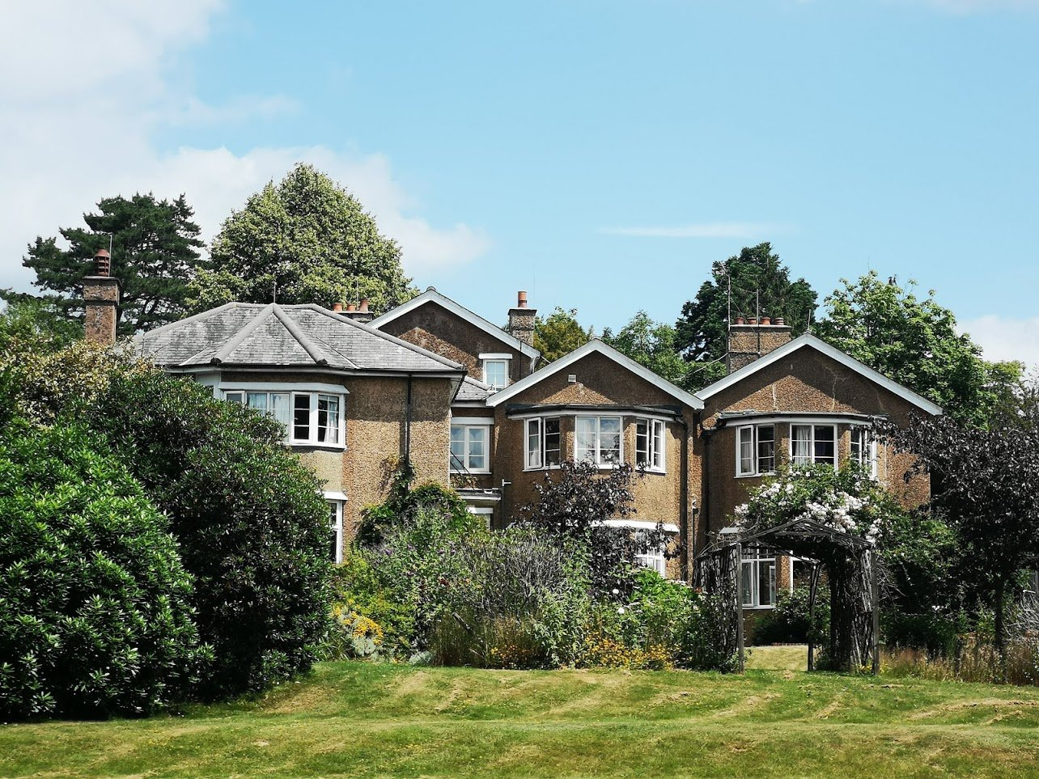

01435863119

services@Tinkershatch.co.uk

New Pond Hill, Cross in Hand

Heathfield, TN210LX

2025 - 2028

Tinkers Hatch green plan

## Tinkers Hatch Green Plan

### **Contents**

1. Foreword ……………………………………………………………………………………………………………….…Pg 3
2. About us …………………………………………………………………………………………………………….….…Pg 4
3. Vision ………………………………………………………………………………………………………………….…….Pg 5
4. Commitments …………………………………………………………………………………………………………Pg 6
5. Road Map …………………………………………………………………………………………………………………Pg 8
6. Next steps – Governance and Communication…………………………………………Pg 11
7. Annex 1: KPIs the ICS will report against ………………………………………………….Pg 14
8. Annex 2: Organisations contributing to East Sussex Green plans ..Pg 17

#

### **1** **Foreword**

The UK government has set a target of achieving net-zero by 2050. These decisions have been made with the growing recognition that we are in a state of climate emergency, which has implications for the planet, but also for people, and specifically people’s health. Unaddressed, it will disrupt care and affect clients and the public at every stage of their lives. With poor environmental health contributing to major diseases, including cardiovascular diseases, asthma and cancer, efforts must be accelerated. Taking action will lead to direct benefits for our clients and the wider public, with research suggesting that up to one-third of new asthma cases could be avoided as a result of efforts to cut emissions. The combustion of fossil fuels is the primary contributor to deaths in the UK from air pollution, which disproportionately affects deprived and vulnerable communities. As we put together our first Green Plan for Tinkers Hatch Ltd, we are consistently reminded of the importance of systems thinking and more integrated problem-solving. By looking at how we achieve health, care and sustainability objectives alongside each other, instead of in silos or in different settings, we will be not only more efficient but more effective at delivering impact. As this is the first green plan for Tinkers Hatch Ltd, this is an executive summary, which sets out joint commitments and strategies for the staff, clients and stakeholders at Tinkers hatch so that we can work collaboratively to try and reach net-zero emissions and manage their common resources more sustainably. Key targets include but are not limited to; embedding environmental sustainability in workforce training, pushing forward the uptake of greener modes of transport, improving energy efficiency in facilities, reducing the over-prescription of medicines and single-use plastic items, cutting down food waste and providing more sustainable food choices, implementing sustainability requirements when choosing supply chain providers, and developing risk mitigation strategies for extreme weather events.

### **2 About Us**

At Tinkers Hatch LTD, we are dedicated to sustainability and environmental responsibility through our Green Plan initiative. As a forward-thinking organisation, we are committed to integrating eco-friendly practices into every aspect of our business operations. Our Green Plan is part of our wider commitment to reducing our environmental footprint and promoting a greener future for all.

Founded in 1984, Tinkers Hatch LTD has grown from a small startup into a thriving small-sized business with a diverse team of over 40 employees. We operate in the Health and Social care sector, with a primary focus on Residential care, respite and day services for adults with learning disabilities. Our head office is located at; 39 High Street, Battle, East Sussex, England, TN33 0EE.

Our key services include:

* Full time residential services
* Day services
* Respite service

We also provide:

* Individual assessment of needs
* Person centred planning & life plans
* Health action plans
* Community integration - via college and work placements
* Choice of living environments
* Well trained, experienced and motivated staff
* 24 hour staff support

Tinkers Hatch LTD is proud of the impact we've started to make in fostering a greener, cleaner, and more sustainable world. We are continually growing and remain committed to expanding our efforts to drive positive environmental change across our organisation and the communities we are part of.

**3. Vision**

At Tinkers hatch we have a vision to create a sustainable future by integrating eco-friendly practices into every aspect of our organisation, fostering a thriving environment where innovation, conservation, and community wellbeing go hand in hand, ensuring a cleaner, greener planet for future generations.

* Environmental Sustainability - Reducing greenhouse gas emissions, conserving biodiversity, protecting ecosystems, and promoting energy efficiency.
* Renewable Energy - Shifting from fossil fuels to solar, wind, hydro, and other renewable energy sources to reduce reliance on non-renewable resources.
* Circular Economy - Encouraging waste reduction, recycling, and upcycling practices, as well as promoting the reuse of materials to minimise waste and reduce environmental impact.
* Sustainable Agriculture and Food Systems - Supporting practices like organic farming, sustainable fishing, and locally sourced food to reduce the carbon footprint associated with food production and consumption.
* Green Infrastructure - Developing energy-efficient buildings, green spaces, and transportation systems that minimise pollution and support long-term environmental goals.
* Social and Economic Benefits - Ensuring that the green transition is inclusive, creating jobs, improving health outcomes, and addressing social inequalities while promoting green technologies and innovation.
* Climate Resilience - Building adaptive strategies to mitigate the impacts of climate change, including infrastructure to handle extreme weather, rising sea levels, and other climate-related challenges.

**4. Our Commitments**

At Tinkers Hatch we are increasingly committed to environmental sustainability, recognising its importance not only for the planet but also for long-term business success.

* Carbon Neutrality and Emissions Reduction

We aim to reduce greenhouse gas emissions through energy efficiency, renewable energy adoption, and the use of carbon offsets.

* Waste Reduction and Circular Economy

We are adopting waste reduction strategies, aiming to minimise our environmental footprint by reusing and recycling materials, reducing single-use plastics, and designing products for longer life cycles.

* Sustainable Sourcing and Responsible Supply Chains

We aim to source materials sustainably, ensuring that raw materials are responsibly harvested or produced.

* Water Conservation

As water scarcity becomes a growing global concern, we aim to implement strategies to reduce water use in our operations and improve water efficiency.

* Biodiversity and Conservation

We aim to integrate biodiversity into our sustainability goals by protecting natural habitats and contributing to conservation efforts.

* Energy Efficiency and Renewable Energy

We will strive to transition to renewable energy sources (such as wind, solar, and hydroelectric power) in the future and enhance energy efficiency across operations.

* Green Building and Sustainable Infrastructure

We will plan to invest in sustainable buildings that meet green building certifications like LEED or BREEAM. This includes implementing energy-efficient designs, using sustainable materials, and minimising the environmental impact of construction.

* Sustainable Transportation and Logistics

We will work to reduce the carbon footprint of our transportation by considering electric vehicles (EVs) in the future, optimising driving routes, and reducing emissions from logistics operations.

* Environmental Impact Reporting and Transparency

We will enhance our commitment to sustainability by publicly sharing our environmental impact and sustainability efforts.

* Employee Engagement and Education

We will create or source programs to engage employees in sustainability efforts, offering training on reducing personal and operational environmental footprints.

* Partnerships and Advocacy

We will strive to collaborate with environmental nonprofits, governmental bodies, and other organisations to promote sustainability on a larger scale.

**5. Road Map to Environmental Sustainability**

1. **Conduct an Environmental Assessment**

* Energy Usage Audit: Review energy consumption to identify areas for improvement.
* Waste Management Audit: Assess waste generation and disposal practices.
* Water Usage Audit: Analyse water consumption and opportunities for conservation.
* Sourcing and Supply Chain Review: Evaluate where products and services are sourced from (e.g., cleaning products, food).

1. **Set Clear Sustainability Goals**

* Short-term Goals: Reduce water and energy consumption, minimise waste.
* Long-term Goals: Achieve carbon neutrality, adopt renewable energy, and implement sustainable sourcing policies.
* Ensure goals align with regulatory requirements for care homes and local sustainability standards.

1. **Energy Efficiency**

* Upgrade Lighting: Replace incandescent bulbs with energy-efficient LED lighting throughout the care home.
* Heating and Cooling Optimisation: Use programmable thermostats, seal windows and doors to prevent heat loss, and consider low-energy heating systems.
* Renewable Energy: Investigate the feasibility of installing solar panels or subscribing to renewable energy sources.
* Energy-Saving Appliances: Replace outdated appliances with energy-efficient models, especially those used for cooking, laundry, and refrigeration.

1. **Water Conservation**

* Install Low-Flow Fixtures: Implement low-flow faucets, showerheads, and toilets to reduce water usage.
* Rainwater Harvesting: If feasible, collect and use rainwater for outdoor cleaning and gardening.
* Regular Plumbing Checks: Prevent leaks by ensuring regular plumbing maintenance.

1. **Waste Reduction and Recycling**

* Minimise Single-Use Plastics: Eliminate disposable plastic items, such as cutlery, straws, and packaging, in favour of reusable alternatives.
* Comprehensive Recycling Program: Separate recyclable waste (paper, cardboard, glass, metal) from general waste, and educate staff and residents on proper disposal.
* Food Waste Reduction: Implement a composting system for food waste and track food waste to adjust purchasing habits accordingly.
* Paper Reduction: Move toward digital documentation and communication to reduce paper usage.

1. **Sustainable Sourcing and Purchasing**

* Eco-Friendly Cleaning Supplies: Use non-toxic, biodegradable cleaning products to minimise chemical pollution.
* Sustainable Food Sourcing: Purchase local, organic, and sustainably farmed foods whenever possible.
* Ethical and Green Products: Source products such as furniture, linens, and toiletries from manufacturers with strong environmental practices.

1. **Green Building Practices**

* Eco-Friendly Construction: If planning for future renovations or new buildings, incorporate green building practices like energy-efficient windows, insulation, and sustainable materials.
* Indoor Air Quality: Ensure proper ventilation, use low-VOC paints and finishes, and incorporate plants to improve indoor air quality.

1. **Engage Staff and Residents in Sustainability Initiatives**

* Training Programs: Provide ongoing staff education on sustainability practices, energy conservation, and waste management.
* Client Involvement: Encourage residents to participate in simple sustainability initiatives, like gardening, reducing waste, or promoting energy-saving habits.
* Incentive Programs: Implement reward systems for staff and residents who adopt eco-friendly behaviours.

**9. Monitor, Report, and Improve**

* Track Progress: Regularly track energy, water, waste, and food consumption to assess improvements.
* Sustainability Reports: Publish yearly or quarterly sustainability reports that outline successes, challenges, and future plans.
* Feedback Mechanism: Create a feedback system for staff, residents, and families to provide input on sustainability efforts.

**10. Community and Collaboration**

* Local Partnerships: Partner with local environmental organisations, green suppliers, or community groups to further sustainability initiatives.
* Community Involvement: Participate in community recycling or environmental events to promote the care home’s commitment to sustainability.

**11. Review and Refine**

* Regularly review the sustainability roadmap to incorporate new technologies, industry best practices, and legislative changes.
* Set periodic check-ins to evaluate goals, assess progress, and adjust strategies accordingly.

This roadmap ensures that sustainability is integrated into every part of Tinkers Hatch, benefiting both the environment and the quality of care provided to residents.

**6. Next steps – Governance and Communication**

Effective governance and communication in care homes are crucial for ensuring not only high-quality care for residents but also for promoting environmental sustainability. Below are some aims to integrate environmental sustainability into the governance and communication structures of Tinkers Hatch.

**1. Governance Structures for Sustainability**

* Leadership Commitment: Tinkers Hatch leadership will demonstrate a commitment to environmental sustainability. This will be reflected in our organisation’s mission, vision, and values, incorporating sustainability goals.
* Sustainability Committee: We will establish a committee focused on environmental sustainability, involving staff members across departments (care, administration, facilities management) to ensure a holistic approach.
* Policy Integration: We will incorporate sustainability into governance policies and practices, such as energy use, waste management, and resource conservation. These policies will align with national or regional environmental regulations and standards.
* Sustainability Reporting: We will track and report our sustainability progress through regular reports, which can be shared with stakeholders such as family members, local authorities, and regulatory bodies.

**2. Communication for Environmental Sustainability**

* Internal Communication: We will regularly communicate sustainability goals and progress with staff through newsletters, meetings, and staff training. Creating awareness among staff about how their actions can reduce environmental impact is essential.
* Engage with Clients: We will engage clients in sustainability efforts where appropriate. For example, residents could participate in gardening,

recycling, or energy-saving initiatives. This engagement not only benefits the environment but also helps improve their overall well-being.

* Family and Community Involvement: We will keep family members informed about sustainability efforts, such as waste reduction or the use of eco-friendly products. Inviting families to participate in sustainability events can foster a sense of community.
* Public Communication: We will publish sustainability achievements on the care home’s website or social media platforms. This helps raise awareness and demonstrates the care home's commitment to environmental stewardship.

**3. Sustainable Practices**

* Energy Efficiency: We will introduce energy-saving measures, such as using LED lighting, energy-efficient appliances, and improving insulation to reduce energy consumption.
* Waste Reduction and Recycling: We will implement a comprehensive waste management system that includes recycling, composting, and reducing food waste and consider digital records to minimise paper usage.
* Green Procurement: We will source products and services with low environmental impact, such as eco-friendly cleaning products, sustainable building materials, and ethically sourced food.
* Water Conservation: We will introduce water-saving technologies like low-flow toilets and faucets and encourage practices that reduce water consumption.
* Sustainable Transport: We will encourage staff to use public transport or carpool. If possible, provide electric vehicle charging stations for visitors or staff.

**4. Monitoring and Continuous Improvement**

* Feedback Mechanisms: We will establish feedback loops where residents, staff, and families can provide input on sustainability efforts. Regular surveys or suggestion boxes can help improve initiatives.
* Benchmarking and Best Practices: We will compare sustainability efforts with other care homes or healthcare facilities to identify areas for improvement. Share best practices with other care homes to raise the industry standard for sustainability.
* Training and Education: We will ensure regular training for staff at all levels on sustainability topics and practices to foster a culture of continuous improvement. This can include waste management, energy efficiency, and other environmental practices.

**5. Challenges and Solutions**

* Resource Constraints: Tinkers Hatch will face budget constraints. A phased approach to sustainability (starting with low-cost initiatives like recycling and energy conservation) can help mitigate this.
* Staff Buy-in: Some staff may resist changes to established routines. Providing training and showcasing the environmental and financial benefits of sustainability can help overcome this resistance.

In conclusion, effective governance and communication for environmental sustainability in care homes involve integrating sustainability into every aspect of the organisation, from leadership commitment and policies to daily practices and staff engagement. By prioritising these elements, Tinkers Hatch can not only improve our environmental footprint but also enhance the well-being of residents, staff, and the surrounding community.

**7. Annex 1: KPIs the ICS will report against**

In a small care home, environmental sustainability can be a key focus for improving operational efficiency and reducing environmental impact. Tinkers Hatch will aim to track the following Key Performance Indicators (KPIs) related to sustainability:

**1. Energy Consumption:**

* Total energy use (kWh): Track the total energy consumption within the care home, including electricity, gas, and heating.
* Energy use per resident: Measure energy use relative to the number of residents to assess efficiency.

**2. Carbon Emissions:**

* CO2 emissions (kg or tonnes): Track the total greenhouse gas emissions generated by the facility, focusing on energy, transport, and waste-related emissions.
* Carbon emissions per resident: Measure the carbon footprint per resident to assess the sustainability of operations.

**3. Water Usage:**

* Total water consumption (litres or cubic meters): Track the total water used, including for laundry, sanitation, and daily operations.
* Water use per resident: Evaluate water consumption relative to the number of residents.

**4. Waste Management:**

* Total waste generated (kg): Monitor the total amount of waste produced by the care home.
* Waste diversion rate (% of waste recycled or composted): Track the percentage of waste that is diverted from landfills through recycling and composting.
* Hazardous waste disposal rate: Measure the amount of hazardous waste produced and properly disposed of.

**5. Sustainable Procurement:**

* Percentage of sustainable supplies purchased: Track the proportion of goods, food, and materials that are sourced sustainably (e.g., local, organic, or eco-friendly products).
* Sustainable cleaning and maintenance products usage: Monitor the use of environmentally friendly cleaning products and maintenance materials.

**6. Green Building Standards:**

* Compliance with environmental building standards (e.g., BREEAM or LEED): Track adherence to green building certifications or sustainable design practices.
* Energy-efficient upgrades (e.g., lighting, insulation, HVAC systems): Record any upgrades made to improve energy efficiency.

**7. Transportation and Mobility:**

* Low-emission vehicle usage: Track the percentage of vehicles used for care home operations that are electric or low-emission.
* Carpooling or public transport uptake by staff: Monitor the adoption of more sustainable commuting options by staff members.

**8. Employee and Resident Engagement:**

* Staff training on sustainability: Track the percentage of staff trained on environmental sustainability practices.
* Resident participation in sustainability programs: Measure the level of engagement by residents in sustainability-related initiatives, such as gardening or recycling programs.

**9. Sustainability in Food and Nutrition:**

* Local and seasonal food sourcing percentage: Track the proportion of meals prepared with locally sourced, seasonal ingredients.
* Food waste reduction rate: Measure the effectiveness of food waste reduction programs (e.g., composting, portion control).

**10. Environmental Impact of Healthcare Operations:**

* Reduction in the use of single-use plastics: Track the reduction in single-use plastic items within the care home, such as straws, cutlery, and packaging.

**11. Sustainable waste management in medical supplies:**

* Monitor the disposal and recycling of medical waste, including pharmaceutical and non-recyclable items.

By setting and tracking these KPIs, Tinkers Hatch can make significant strides in improving its environmental sustainability while contributing positively to broader public health and environmental goals.

**8. Annex 2: Organisations contributing to East Sussex Green plans.**

Several organisations have contributed to green plans in East Sussex, supporting sustainability and environmental efforts in the region. Some key contributors include:

**East Sussex County Council (ESCC)**

As the local government authority, ESCC has been involved in promoting green initiatives, including carbon reduction strategies, waste management, and promoting renewable energy projects.

**Sussex Wildlife Trust**

This charity works to protect the wildlife and natural habitats of Sussex, supporting biodiversity and conservation projects, often in collaboration with local communities.

**The Green Deal Communities**

Various projects under the Green Deal Communities scheme focus on making homes more energy-efficient, reducing carbon footprints, and supporting sustainable living.

**Friends of the Earth**

This environmental charity campaigns for climate action, and local branches in East Sussex engage in initiatives related to air quality, waste reduction, and sustainable transport.

**Brighton & Hove City Council**

Though a neighbouring authority to East Sussex, Brighton & Hove has close collaborations with East Sussex councils on environmental projects such as promoting cycling, sustainable transport, and renewable energy solutions.

**The Carbon Trust**

The Carbon Trust works with businesses and public sector organisations in East Sussex to help reduce carbon emissions through energy efficiency programs and advice.

**The Energy Savings Trust**

This organisation supports East Sussex residents and businesses in improving energy efficiency, reducing energy consumption, and transitioning to greener energy sources.

**Transition Town Lewes**

A community-based organisation focused on local sustainability, Transition Town Lewes works to create a more resilient and sustainable community by addressing food, transport, and energy.

**The National Trust**

With properties in East Sussex, the National Trust contributes to land conservation, promoting sustainable farming practices, and environmental education.

**Local Environmental Groups and NGOs**

Many smaller local groups, such as community garden projects, clean-up initiatives, and environmental advocacy organisations, play a role in pushing for green policies and educating the public.

These organisations, along with businesses, local residents, and other stakeholders, work together to implement green policies and programs, supporting East Sussex's environmental goals.